https://lh6.googleusercontent.com/_cCVYVgWtl69X8eXz17wd3XvMbeqUypa6Hx1jknNTzgkl3NlhOkV0alax9mRliSj23s-UUaQz5NGFEAUgKi7yc-63yADb1CrTA7cYwDLTuoII5fB9X0BGLxmM8THF8tSvH6sYwdH



**Design Document for**

**Anturions**

06.10.2015

**───**

Yu-Ching Ho

Muthar Chaudhry

David Smith

# Game Overview

## Summary

Humans have landed on Mars and to survive and colonise their centre, they need to connect to a water source. Humans discover and build a relationship with Mars’ inhabitants - the Anturions. The Anturions are ant-like creatures that are able to dig through Mars’ surface and create a network of tunnels and bridges in order to direct the flow of water to the human settlement.

Anturions at its core is a simple 2D side scrolling puzzle game. The Anturions will enter the map, your job is simply to guide them to a water source so tunnels can be dug to direct the water flow. Sometimes, other objectives may be present, this will be shown to you before the level begins. If you have played the game Lemmings, then you will be familiar with the core mechanics of our game.

### Why create this game?

We felt that with such a small team of people, we would be best to try and keep the creation of the game as simple as possible and try aim for a market where although lots of competition, the money invested isn’t quite as substantial. We feel that the mobile platform is perfect for this. Examining the market, we noticed that many of the games created on the mobile platforms seem to resemble each other quite a lot, so coming up with new ideas could be beneficial and we hope to do just that. Include the subject of the colonisation of Mars into the mix helps to draw interest.

### Our Focus

Our main focus is to create a game which people can pick up and play without too much of a steep learning curve. We’re looking to create a game people can play on the go even if just for 10 minutes. The replay value will be a big focus for us. We want to encourage the player to complete levels over in order to gain a better score. This will be strengthened by allowing the player to gain extra Reputation Points (RP) by replaying previously completed levels which they will then use to increase the amount of Anturions available on a level.

# 

# 

# Gameplay

## Overview

At the beginning of each level the Anturions will arrive via the starting point which will be a tunnel connecting to the current level. One Anturion will arrive at a time and then each consecutive second another will arrive. This will continue until the total Anturions have left the starting point. You will be able to select extra Anturions to use before the levels begin by spending points that you earn after each level. The more Anturions that survive, the more points you get to spend.

The Anturions are docile creatures that will just walk back and forth, changing direction each time they bump into a solid object. They will not complete any actions unless specifically told to do so by the player. The player will do this by selecting an Anturion, then choosing the appropriate action or upgrade shown at the bottom of the screen. Various actions and upgrades will be available. The objective is to connect a water source to the human hub on the map.

Examples of some actions:

**Digger** - The Anturion will dig in the direction it is currently moving in. Use this against a wall and it will continue to dig a passage until reaching the other side or another action is assigned to it.

**Bridges** - Like ants, the Anturions will use themselves to create bridges over small holes. They will connect themselves to each other until told to stop building. At this point the rest of the Anturions will walk over the makeshift bridge.

**Jump** - As simple as it sounds. The Anturion will jump a small distance in the direction it is facing. This can also be used to leap over small objects.

**Exoskeleton** - The Anturions outer skin will become as solid as rock, allowing it to take extra damage from the environment. Unlike Fire Anturions, It will not become immune to lava but it will be able to prevent damage from hostile conditions or obstacles (large carnivorous plants, falling rocks, etc.), falling however will still hurt it.

**Endoskeleton** - Strengthens the Anturions inner skeleton to prevent it from taking any fall damage.

**Fire Anturion** - An upgrade for an Anturion that will make it immune to hot conditions. This can be used to allow it to walk over or through the surface of lava or any other hot obstacle (steam, acid rain, lava, etc.).

These are just a few examples of the various utilities the player will have available during playing. Each level will only allow the player to use a limited number and won’t always have access to all of them. This forces them to use them wisely.

## Player Controls

Throughout the game, you will not exactly control the Anturions in the manner in which would be expected. Unlike most games, you will not have control over them directly. They will simply enter into the level from one direction and continue to walk that way until an obstacle is met. At this point they will turn around and walk the other direction. They will be oblivious to the dangers around them and quite often walk to their deaths unless you stop them.

What you will have control over, is a certain set of actions and upgrades in which you can apply to the Anturions when you feel necessary and these upgrades will allow them to navigate through the various obstacles met. These can vary from turning them into Fire Ants where they would be immune to flames or lava, or simply commanding them to dig, where they will continue to dig until they reach the other side or commanded to stop. You will only be given a certain amount of these upgrades or actions each level and this can also depend on your reputation with the Queen Anturion. Reputation will be based on level performance, a score given based on the amount of Anturions that survived.

## Characters Controlled

As previously stated, you will not really control any characters but rather you control actions and upgrades in which you will apply to the Anturions when you feel necessary. The number of Anturions each level will be based on your reputation. Your reputation with the Queen Anturion will be calculated at the end of each level based on how many Anturions survived. The lower your reputation, the lower the number of Anturions you will have.

You will be able to replay levels in order to gain more reputation which you can then use to increase the amount of Anturions you have in the next level. This gives the game a nice replay value as well as never putting the player in the position where they have to restart the entire game because they have scored too little. Replaying the levels to better your score is something we will encourage and also gives the player the option to earn more Reputation Points.

## Victory Conditions

Each level in Anturions will have the goal of either reaching the water source or directing the flow of water to a specific location or simply to reach an exit point. To direct the water, the Anturions will need to think about how the water is going to flow through the tunnels dug so not only will the player need to think about how to navigate around the obstacles but also how to create a tunnel system to direct the water.

## Time

Each level will track the player's time taken. This will be one of the variables used in order to calculate the score at the end of the level. The number of Anturions that survive at the end will also have a major impact on the score. This score will then be converted into Reputation Points (RPs) which the player will then be able to use to add more Anturions in upcoming levels. A slider at the beginning of the level will be used to select how many they desire.

Timed missions and objectives may also be present in some levels. This could be instances such as the player needing to provide water to a local settlement in order for them to use it to produce oxygen. If the player doesn’t complete it in time then the humans will run out and suffocate. Another instance may be an incoming storm which will make the mission impossible to complete when the time runs out. These are just a couple of examples of how we would use time to affect the conditions of play.

## Story and Cut-Scenes

Although Anturions is just a simple puzzle game, we have decided to include a basic storyline. The story will be told to the player in a series of comic book style cut-scenes before and after each level and these comic strips will contain little to no animation at all. Throughout the story you will meet various characters like the Queen Anturion, Humans and sentient Anturions in DLC’s. The Anturions you control during the game will be lacking in perception so won't appear in the story itself as they are just controlled by the Queen Anturion like drones.

The story will begin when Humans are on Mars searching for water sources. Scientists discover a way to communicate with the indigenous lifeforms called the Anturions. They convince the Queen Anturion to aid the humans in looking for water sources by using her drones to dig arounds caverns underground to hunt for water. Various events will take place which aid in giving depth to the levels played throughout the game.

# The Game World

## Overview

The game world will be set around various different locations on Mars, both above and under the surface. It will be presented to the player in two different ways. During the game the player will be presented with a side on view of the world, much like many platform games of the past. Between levels the player will be able to select from a variety of missions to undergo which will be displayed via an overhead map.

## World Features

Mars will feature a number of different environments, each with its own eco system under the thick surface. This will create various kinds of obstacles that the player will have to take into consideration when trying to reach the water source. Harsh conditions such as lava, hot steam, toxic water, etc. may sometimes be present on the level. Mars also has various plant life under ground, some of which are carnivorous and will eat any ants that go near them. Falling rocks may also cause difficulties as sometimes some of the caves may be somewhat fragile.

## Key Locations

Anturions will be split up into several different chapters. Each chapter will be set in a different location on Mars and sometimes with unique climates. For instance, the first chapter could be set beneath the planet's surface in a series of caves and caverns, the next could be in a location with harsh sand storms, others might have lava rain and sometimes even icy climates.

In order to play more chapters of the developing storyline, players will be asked to purchase them much like a DLC. The first 4 levels of the purchasable chapter will be free. In order to unlock the full version, players will need to purchase the rest of the chapter. We decided to use this payment method so people can demo the first part of the chapter for free and then purchase if they so desire.

## Weather & Climate

Many of the climate conditions in Anturions may only be there for aesthetic reasons but a few will have gameplay consequences too. Some of the suggested weather conditions and how they affect the game are as follows.

**Acid Rain** - Acid will burn to death anything it comes in contact with. Some levels may be designed with the player having to take the Anturions to the surface and Acid Rain will kill any of them that are not protected.

**Radiation** - Will slowly dissolve the skin of any living thing it comes into contact with. Will be shown as a green kind of fog to the player. Deadly to anything that it comes in contact.

**Geysers** - Will be placed in various locations around a level and every so often spit out some hot steam or lava which will burn the Anturions, killing them, if they are not properly protected with Fire Anturion armour.

# Rendering System

The style of graphics we have decided to use for our game will be something similar to old school retro games. We feel it would be best to keep the sprites simple with as little detail as possible but with enough to reflect the artistic style of the game and artists. We are looking to create a game with bland but beautiful colours which we feel is the best way to reflect how life on Mars would be. It would be a struggle to survive but also beautiful and majestic. Our artistic inspirations come from artists such as Zdzislaw Beksinski and H. R. Giger but with a more comical approach similar to Tim Burton. All art in the game will be kept 2D in order to keep it as simple as possible. Nothing will be rendered in 3D, keeping the cost down as well.

## Camera

The entire game will be played like a side-scroller. You will be able to move the camera left, right, up and down in order to show the complete level. You will also be able to zoom in and pan back out to show the complete map of the level. The maximum zoom will show the Anturions at about a quarter the size of the screen. The player will also be able to lock the camera onto any Anturion if desire. This will help follow the character around while the player can concern themselves with getting certain actions ready to use to navigate around obstacles.

## Game Engines

We have taken a look at various different game engines we could use to produce this game. Each one comes with its own set of pro’s and con’s. Some of them also being free to use while others costing a small amount. We have taken each one into consideration when deciding on our final pick. The two main choices were Unity and GameMaker. Others we considered were GameSalad and App Game Kit.

**Unity** - A cross-platform game engine developed by Unity Technologies, a company whose sole purpose is to create a usable gaming engine at an affordable price. David Helgason (CEO), Nicholas Francis (CCO), and Joachim Ante (CTO) started the company in 2014 after one of their games, GooBall, failed to make sales they had hoped for. The engine has since went on to win a number of awards and the company is known to be a great asset within the gaming market.

**GameMaker** - A proprietary gaming engine created in Dundee, Scotland by YoYo Games. Its initial release was in 1999 and is known for its simple drag and drop action sequences and its sandboxed scripting language known as Game Maker Language which can be used for more advanced users. It is designed to allow novice programmers to be able to create video games without having to learn complex languages such as C++ or Java via its use of the drag and drop system therefore simple to use and affordable.

In the end we decided to go with GameMaker. This felt like the right pick as we are all familiar with the engine - having used it last year - and it keeps the development quite simple, allowing us to concentrate on creating unique levels that the player will enjoying playing while at the same time not finding them too easy or difficult to complete.

### Water

Water in Anturions will act much like you would expect it to work in the real world. Gravity will affect the flow and it will collide with any obstacle in the way. The player will need to take this into consideration when thinking about how they are going to direct the flow of water to the location specified. They would most likely want to create a series of tunnels dug out by the Anturions which lead to the desired destination. This will often not be too far away from the water source but may also sometimes be at the other side of the level.

# Game Characters

## Overview

Throughout the game, the player will meet various characters which will help unfold the story around them. These will include a number of both Human and Anturion. The player will not directly play as any of these characters but they will at times be given mission briefings from them and gain favour over time. The characters will be introduced to the player in a series of comic strips which will tell the story between each level. The Anturion Queen will play a major role within the story and you will have to gain reputation with her in order to progress through the game.

## Anturion Inspirations

One of the main influences for the design of the Anturions originally came from artwork from H. R. Giger. As the project expanded we felt that while it wasn’t fully suitable for the kind of game we would like to create, we would still like to borrow from the creepy alien like artwork he produced. This led us onto art by a similar artist called Zdzislaw Beksinski. We agreed that the game would have a quirky cartoon feel so the style of art we looked at became similar to Tim Burton's.

|  |
| --- |
| Fig 1. H.R. Giger Alien artwork |

|  |  |
| --- | --- |
| Fig 2. Mutated cockroach from Terraformar | Other inspirations were from a manga known as Terraformars illustrated by Kenichi Tachibana. The manga is about terraforming Mars with the help of cockroaches. However after several hundred years, the cockroaches have mutated and genetically-modified humans with insect or other animal bases battle with mutated cockroaches who have become sentient and dangerous. |

|  |
| --- |
| Fig 3. The Elements and Joined Together by Tim Burton |

Anturion Concept Art

A rough design of Anturions and how they may look.

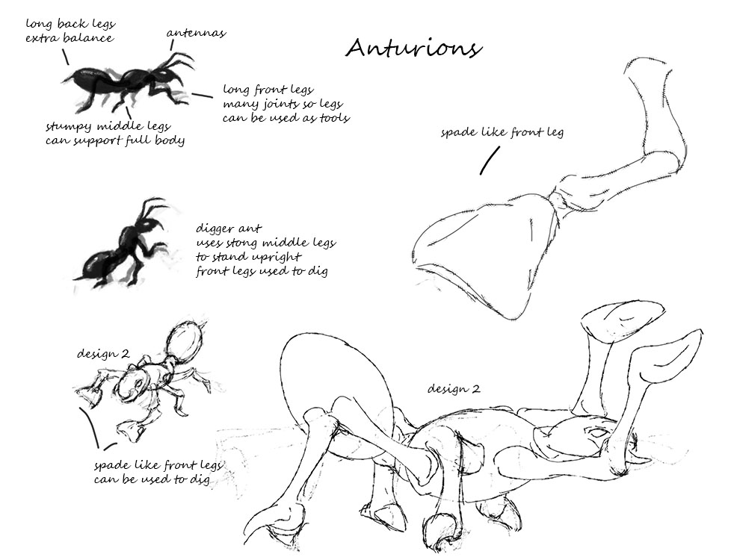

## Dangers

Mars may look like a desolate barren planet on the surface, but beneath the core various plant life have been able to thrive especially around where water sources may be found. These plants have grown to such a size that they are often very hazardous to Humans and Anturions. Carnivorous plants similar to the Venus flytrap can sometimes prove to be quite hostile especially as some of them are camouflaged within other plants. These will provide dangers to the player if any Anturion was to wander too close.

The cave systems on Mars are at times fragile at best. This is another danger which will come into play that the player will need to take into consideration. Weak structures may often collapse, killing anything beneath and maybe even making it impossible to continue. Falling rocks, cave-ins, endless pits to fall in, slippy surfaces are just some of the dangers we would like to include in the game.

# 

Fig 4. Carnivorous plant drawn by Anisis

# User Interface

Anturion will be a touch-screen game. A control bar will run along the bottom of the screen; and will also show upgrades of each of the Anturions when the player selects them. Visual cues will also aid in sometimes allowing the player to determine what upgrades each of the Anturions have. A zoom button will be available at the bottom right of the screen to allow the user to zoom in and out.

At the top of the screen a small bar will show the stats for the level - e.g. score, time, Anturions still to arrive, Anturions alive, and anything else relevant for that particular level.

# Musical Scores and Sound Effects

## Music Inspirations

Music has always been an important aspect of videos games. Sometimes even more important than people realise. It can often help set the mood for the game and in many instances certain songs become iconic. For our music we would like to create something calm but also memorable and meaningful. We would borrow influences from classic games such as Cannon Fodder, Turrican, Alien Breed, Final Fantasy and many more.

### Background Music Samples

Cannon Fodder

<https://www.youtube.com/watch?v=55cbGTlgHqI>

Turrican Soundtrack

<https://www.youtube.com/watch?v=8SrBGpPHiEQ>

Turrican II

<https://www.youtube.com/watch?v=_duwZgikoHM>

Alien Breed

<https://www.youtube.com/watch?v=BQgVwM3aEt0>

Final Fantasy 6

<https://www.youtube.com/watch?v=jjgwVSDAmP4>

Amiga - Cannon Fodder Recruitment Music

<https://www.youtube.com/watch?v=55cbGTlgHqI>

## 

## Voices

Cut-scenes in the game will all be text based. No voices will be present during them but during the game we would like to include small clips of cute little voices whenever the player performs an action. These voices will be along the lines of classic games like Oddworld: Abe’s Oddysee, Worms Armageddon, Minions and others.

### Samples

Oddworld: Abe’s Oddysee

<https://www.youtube.com/watch?v=6FC4lA7BNnM>

Baby Goat’s Cry

<https://www.youtube.com/watch?v=DV_3qx-oBms>

Cameramen have feelings

<https://www.youtube.com/watch?v=mkc2z7qTrXQ>

Minions

<https://www.youtube.com/watch?v=WBJDNmmzH6E>

Chipmunk sounds

<https://www.youtube.com/watch?v=-hTV6-uVQvE>

# References

Fig 1. H.R. Giger Alien artwork

<http://thecreatorsproject.vice.com/blog/original-creators-biomechanical-surrealist-hrgiger>

Fig 2. Mutated cockroach from Terraformar

<http://terraformars.wikia.com/wiki/2nd_Mission>

Fig 3. The Elements and joined Together by Tim Burton

<http://members.tripod.com/~multiple_monsters/timburton.html>

Fig 4. Carnivorous plant drawn by Anisis

<http://anisis.deviantart.com/art/Carnivorous-plant-171269142>

# Business Report

## Cost & Development

The development costs of this project aren’t that high since it is plausible to make the game ourselves. There are a few areas where there will be money involved to complete this game: the cost of advertising in-game, purchasing a pro-version of GameMaker, a 1-time registration fee and the making of music. It is hard to calculate the cost of the advertising in other app games therefore we didn’t give it a value. Purchasing “GameMaker: Studio Professional” for the full price is $150 but even then, there are massive sales and humble bundles to get the product for a very cheap price.

To upload games on the Android market, a Google Play account has to be registered, and then you’ll have to pay a 1-time registration fee to download Android SDK. For music, we could ask a friend who can make background music or hire someone to make music. We also took a look at Magnatune and the prices to use a song came to around $1500. Jonathan Blow who created Braid, used music from Magnatune and here is a link to his blog talking about it: <http://braid-game.com/news/2008/08/the-soundtrack-to-braid/>

## Money

We mainly want to make this game for our own experience, but we have 4 ways of making money - players being able to purchase chapters, purchasing RP, voice-packs for Anturions and having advertisement inside our game. Players can buy upgrades or more Anturions with RP however players can also use money to unlock them. Chapters are only unlockable with money - but as said earlier - they have 4 levels free to demo.

With in-game advertisement, we feel that when a player makes any purchase with money, the advertisement will be gone. A bonus for paying for the game no matter how much the amount. We estimate the cost will be around £15,000 for everything like the hiring programmers, animators, musicians, game testing and advertising with any other costs.

Since the game is free, when you purchase with RP, the price per RP gets cheaper the more you purchase at once. When buying a chapter, a chapter would cost £1. We feel that the time it will take for the game to break- even will be about 6 months to 1 year.

Players can also purchase voice packs with money, and it will give the game a different feel. The example voices are listed above.

## Marketing

When researching marketing and advertising of the game, this website was referred to a lot.

<http://gamedevelopment.tutsplus.com/articles/marketing-your-indie-game-the-single-most-important-thing-that-no-one-knows-how-to-do--gamedev-7157>

When you have something that illustrates the fundamental mechanics and look of your game, begin your marketing like one finished level or a small demo of the gameplay.

From there, generate interest as soon as there is something to show to the public and then promote progress of game on semi-regular basis through these sources.

* Website
  + Captivating screenshots
  + Trailers which demonstrate gameplay
    - Target each facet of gameplay at least once
    - Clearly display the game’s title
    - Keep cut-scenes down to a minimum
  + A media page that houses images of videos
* Social Media, posting your updates
  + Facebook page
  + Twitter page
  + Reddit
* Development blog which talks about the growth of the game, personal struggles and triumphs

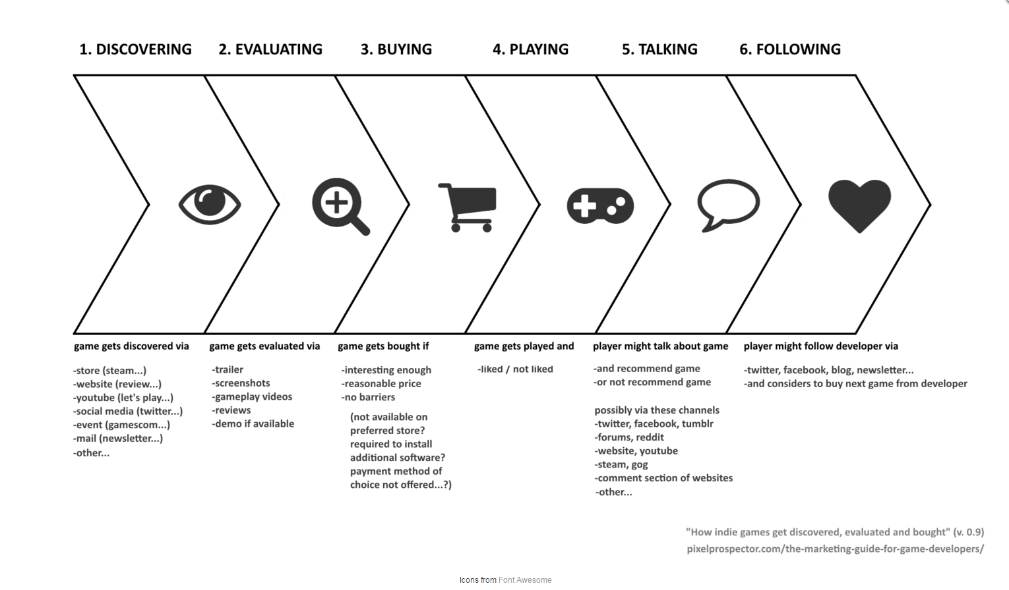Illustration process image- <http://www.pixelprospector.com/>